Research Methods
AQA A level (Yr13) Component 2



Paper 2  Candidates should be able to: - | GREEN | AMBER | RED
3.2.3
Research Methods

Experimental method: Lab and field, natural & quasi experiments
Observational techniques: Naturalistic, controlled, overt, covert, participant
Self-report: Questionnaires and interviews
Correlations: Analysis of the relationship between co-variables
Content Analysis
Case Studies
3.2.3.1
Scientific processes

Aims
Hypotheses; directional and non-directional
Sampling: Random, systematic, stratified, opportunity, volunteer
Pilot studies
Experimental Designs: Independent measures, repeated measures and matched pairs designs
Observational Design: behavioural categories, time and event sampling
Variables: Independent and dependent, extraneous variables, operationalisation of variables
Control: Standardisation, counterbalancing and randomisation
Demand characteristics and investigator effects
Ethics
Peer review
Implications of Psychological research for the economy
Reliability: across all methods; test-retest and inter-rater reliability
Validity: across all methods; face validity, concurrent validity, ecological validity and temporal validity
Features of Science: objectivity, empirical method, replicability and falsifiability, theory construction, hypothesis testing, paradigms and paradigms shifts
Reporting psychological investigations: - abstract, introduction, method, results, discussion and referencing
3.2.3.2
Data Handling and analysis

Quantitative and qualitative data
Primary and secondary data: including meta-analysis
Descriptive statistics: Measures of central tendency, Measures of dispersion, percentages and positive, negative and zero correlations
Graphs & charts
Distributions; normal and skewed
Correlation co-efficient
Levels of measurement: nominal, ordinal and interval
Content analysis and coding: Thematic analysis
3.2.3.3.
Inferential Testing

Sign Test
Probability and significance: Statistical tables and critical values, Type I and Types II errors
When to use the following tests: Spearman's rho, Pearson's r, Wilcoxon, Mann-Whitney, related t-test, unrelated t-test and Chi-square test

Content Analysis

Content analysis is a research tool used to indirectly observe the presence of certain words, images or concepts within the media (e.g. advertisements, books films etc.). For example, content analysis could be used to study sex-role stereotyping. Content analysis is usually carried out on secondary data e.g. data already published.
Researchers quantify (i.e. count) and analyse (i.e. examine) the presence, meanings and relationships of words and concepts, then make inferences about the messages within the media, the writer(s), the audience, and even the culture and time of which these are a part.
To conduct a content analysis on any such media, the media is coded or broken down, into manageable categories on a variety of levels - word, word sense, phrase, sentence, or theme - and then examined.

Waynforth & Dunbar (1995) carried out a content analysis of Lonely Hearts Columns. They discovered distinct gender differences in the way that men and women advertised themselves. Whilst males advertised resources (e.g. job, house, car etc.) and sought attractive, youthful partners, woman advertised their attractiveness (petite, blonde, blue eyes) and sought resources.

Advantages & Disadvantages of Content Analysis

Advantages | Disadvantages

Task: - Using a highlighter analyse the adverts below, use one colour for resources and another for attractiveness.

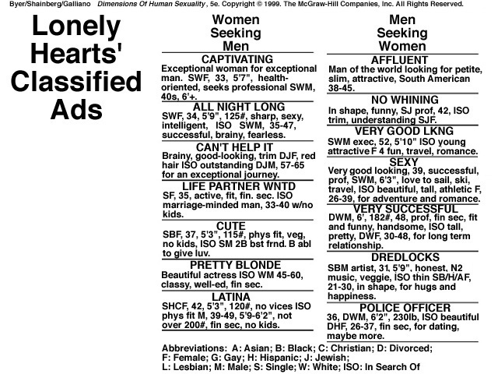

Complete the Table

 | Offer Resources | Offer Attractiveness | Looking for Resources | Looking for Attractiveness
Males
Females

What does this tell you about how males and females advertise themselves and what they are looking for?

Content Analysis and Coding: Thematic Analysis

So far we have looked at quantitative analysis, now we are going to look at how to analyse qualitative data in a content analysis.

To re-cap: - Content analysis is a research tool used to indirectly observe the presence of certain words, images or concepts within the media (e.g. advertisements, books films etc.). For example, content analysis could be used to study sex-role stereotyping. Content analysis is usually carried out on secondary data e.g. data already published.

Researchers analyse (i.e. examine) the presence, meanings and relationships of words and concepts, then make inferences about the messages within the media, the writer(s), the audience, and even the culture and time of which these are a part.

To conduct a content analysis on any such media, the media is coded or broken down, into manageable categories on a variety of levels - word, word sense, phrase, sentence, or theme - and then examined.

Thematic analysis as the name suggests looks for emergent themes in data, codes them and then interprets their meaning.

For example, read the following article: -

Karen Taylor, 19, struggled with her new baby until she admitted she had a problem and found help.

“It wasn’t until Jamie was about five months old that I started feeling low. I’d gone back to college, and Jamie had started at a day nursery, and he just seemed to catch every bug that was going.

“He was ill every few weeks, and would wake up six to eight times a night. I was only getting about four hours’ sleep a night. I had recently split up with Jamie’s dad, and I just felt that I wasn’t coping.

“I was living with my parents and my brother, but I wouldn’t let anyone help me with the baby, because I didn’t want to admit that I was having trouble. It would have been like admitting defeat. But I was crying myself to sleep at night, hardly sleeping at all, and not eating properly, and I started feeling ill.
"It was only when I began a parenting course that things changed. Sam, my tutor, was fantastic. She could see something was wrong, and put me in touch with a counselling service.

“But the biggest step was admitting to other people, and to myself, that I needed help. It was the hardest thing to do. I’m very stubborn, and felt I had to cope. Once I talked to them, I got more support from my family and friends. Jamie started sleeping better, and so did I, and I stopped feeling I had to be supermum.

"I realised that to be a good mum to him, I had to be good to myself. It didn’t happen straight away, but gradually I felt better. I feel so positive now. I’m back at college and back with Jamie’s dad. When Jamie, who is now 16 months, calls me Mum I know it’s all worth it.”

1. List the clinical characteristics of depression below and give each one a code

2. Write your code next to the part of the discourse where you feel Karen is displaying the symptom.

This is an example of Top Down analysis as you started with an idea that this was a case of depression and applied the symptoms of the disorder to the article.

Bottom Up analysis is much more open ended, no initial assumptions are made. It is a bit like the difference between a structured (top down) and unstructured (bottom up) observation.

Read the following article: -

Sandra, a corporate lawyer, had been losing weight after a painful divorce.

“I’d become desperately concerned about my children’s after-school sports activities. I sipped water or chewed food a certain amount of times on the left side of my mouth in order to prevent “something bad” happening to my children.

“Despite a lifelong apprehension toward prescribed medication, I was using sleeping pills to stop these thoughts long enough to sleep.

“Things came to a head when the children told my mother that they were being encouraged to scrub shoes, take a shower, and change clothes on arriving home from school. Taking seriously a well-intentioned threat to go to the authorities, I felt both betrayed and exposed by my children.”

“Within weeks, I was able to address nearly all my thoughts and actions. Later modules of the programme proved more difficult, and I needed many additional weeks of support.”

1. Highlight the abnormalities in Sandra’s behaviour

2. Write down the clinical characteristics you think she is displaying and codes that you would give them

3. Based on the clinical characteristics you have identified, what would you diagnose her with?

Evaluate Content Analysis

Strengths | Weaknesses

Case Studies

This is the research method used extensively by Sigmund Freud and favoured by Child Psychologists and Social Workers.

A case study is an in-depth study, using a range of methods on one person or a small group. Because it uses a range of different research methods, this increases reliability, by the process of triangulation. Using a range of different methods is a way of double-checking results.

Task: -

A child in a primary school is giving his/her teacher cause for concern. This child is very disruptive, finds it hard to concentrate and is not making progress. The teacher decides to call in an Educational Psychologist to investigate the problem and, hopefully make some recommendations to improve the situation.

How would the Educational Psychologist conduct this case study? What methods would be used and what sources of data would be collected?

Make notes on the advantages and disadvantages of this method of research.

Advantages | Disadvantages

Sigmund Freud and the use of Case Studies as a Research Method

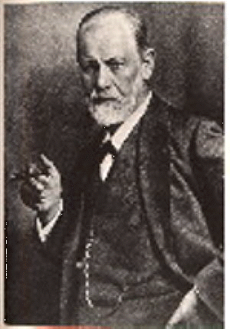
Sigmund Freud, the most famous psychologist of all, used case studies extensively in his work. From the findings of relatively few case studies he proposed a theory – psychoanalytical theory. This theory suggests that behaviour is the result of unresolved motivations and desires. Of particular importance is what happens to us in our childhood. A problematic childhood will, according to this perspective, have lifelong effects. Some of his most famous case studies are: Dora, Anna O, Rat Man and Little Hans (all false names to preserve patient confidentiality).
Freud used a case study method to investigate Little Hans’ phobia. However, the case study was actually carried out by the boy’s father who was a friend and supporter of Freud. Freud probably only met the boy once. The father reported to Freud via correspondence and Freud gave directions as how to deal with the situation based on his interpretations of the father’s reports.
Read the following and extract: -
A case study by Freud is ‘Little Hans’ (1909), who developed a phobia of horses. Hans was 5 years old and developed his fear after seeing a horse that was pulling a carriage, fall over and kick his feet in the air. Little Hans was terrified, and thought that the horse dead. According to Freud, Little Hans was experiencing the ‘Oedipus Complex’ wanting to possess his mother, and saw his father as a rival. He displaced the fear of his father onto horses. The blinkers on the horse reminded Little Hans of his father’s glasses, and the black around the horse’s mouth reminded Little Hans of his father’s beard and moustache!

Freud believed that Little Hans provided evidence to support his theories of child development. He thought that Hans was suffering from an Oedipus conflict, his intense love for his mother led him to see his father as a rival and he wanted to get rid of him. This caused him psychological conflict, which was manifested in a castration complex (he subconsciously felt his father would punish him for his feelings towards his mother) and his phobia of horses. Freud argued that Hans had projected his fear of his father onto horses.

Do you agree with Freud?

What other explanations could be offered for Hans’ fear?

What are the limitations of this case study?

As an interesting postscript to this story, Hans finally met Freud when he was 19. Freud reported that he was an extremely well adjusted, fit and healthy young man. When Hans read his own case study he had no recollection of his early fear of horses or his discussions with his father about it.
Reliability

Reliability refers to the consistency of a test or procedure. It is important to establish reliability when undertaking research. One aspect of reliability involves assessing the consistency of measurement between different observers (Inter-rater reliability). Another involves achieving consistent measuring instruments when developing tests.

Inter-rater Reliability – Would two observers, experimenters etc. come to the same conclusion or score? (e.g. multiple-choice questions would have high scorer reliability; essays might be lower as there is an element of interpretation.) Both researchers must be trained in the same way and in order to establish reliability there must be an 80% concordance rate (agreement) between the two researchers.

Test-retest – Would the results be consistent in a second test?

Measuring Validity

Measurements and findings are valid if they are accurate. How realistic is the study, does it compare to real life?

Face Validity – Does it look OK? Would common sense tell us that the test should work?

Predictive Validity – Predicts future performance with some accuracy e.g. GCSE results predict possible A level results.

Concurrent Validity – Compares two methods of testing to see if results are comparable. Often used to compare a new test with an established one. E.g. new A level system with old AS/A2 level system.

Ecological Validity – Can the findings of research be generalised to other settings beyond the laboratory e.g. would it work in real life.

Temporal Validity – Although the results might have been true in that time period, things change and the results might not be valid today e.g. Asch, Milgram etc.

The greater number of ways a test has been shown to be reliable and valid, the more confident we can be when using it as a research tool and the more confident we can be about our results and conclusions.

Task: -
Questions on reliability and validity.

- A Level grades are used by Universities. Why? What type of validity does this display? What are the possible problems with this?

- What are the problems involved in using test-retest reliability?

- When could you use face validity? Give an example.

- Define the terms reliability and validity in your own words.

Features of Science: Psychology as a Science

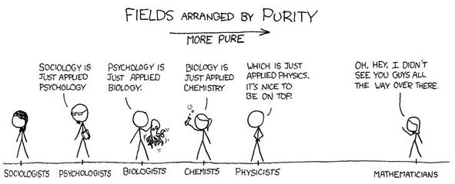

The word Science comes from the Latin word scientia meaning knowledge. Therefore using this narrow definition psychology is definitely a science as it is all about gaining knowledge of human behavior through the scientific method.

The question of whether or not psychology is a science is important as science is highly valued in our society. For example, the phrase ‘follow the science’ has been very important during the Covid-19 pandemic of 2020/21.

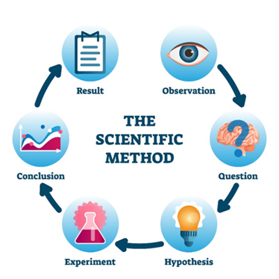
Science uses an empirical approach, which means that knowledge comes through experience gathered through our five sense. In psychology we use experimental and non-experimental research methods. It is the experiment method which is considered an empirical method.

From empirical observations a research question arises and then a hypothesis is generated that can be tested through controlled experimentation. A theory is formulated which can then be used to predict future behaviour.

Researchers should be objective, which means they should, as much as possible, be free from bias. One way to try and ensure objectivity is by the standardisation of procedures and control of all extraneous variables. This standardisation and control also makes experiments replicable (able to repeat), which increases reliability.


According to the American philosopher Thomas Kuhn, a science should have a shared set of: -

- Assumptions
- Scientific methods
- Terminology

Whilst psychology is clearly succeeding in b) and c), we use the scientific method by setting up experiments to test our hypotheses and we do have specialist vocabulary, a) is slightly more contentious.

The fact that within psychology there are conflicting explanations and assumptions about human behavior has led some to label psychology as unscientific. However, this is an unfair critique as there are conflicting opinions and assumptions in the natural sciences too. Also, Psychology is a relatively young science and still testing and refining theories. Remember: - No theory in science is final.

A science should provide precise (operationalised) hypotheses which can be tested in order to support or refute a theory.

Psychology does try to aspire to this goal, however, some aspect of human behavior and cognition are not so easy to define (operationalise) For example, it is difficult to be precise about things such as intelligence as there is no agreed upon definition of exactly what intelligence is.

Scientific Paradigms

Thomas Kuhn argues that the social sciences are fundamentally different to the physical sciences. He is suggesting that psychology belongs in the social science grouping (which is contentious). Kuhn argues that the physical sciences could hold one unifying theory or paradigm (the world is flat) which may then shift when new evidence is discovered (the world is round). However, he argues that this cannot apply to the social sciences as there is not one unifying theory upon which we could test our ideas.

Behaviorism was once seen as a possible unifying theory for psychology, it was popular for its scientific simplicity, simple laws of cause and effect. However, it is far too simplistic to explain the complex phenomenon which is human behavior. Likewise biological theories are considered reductionist. In reality, it is the complex interaction between nature and nurture which is required to understand human behavior. The unique human attribute of free will means that studying human behavior will never be straightforward or easy, but it is infinitely more interesting.

Falsification

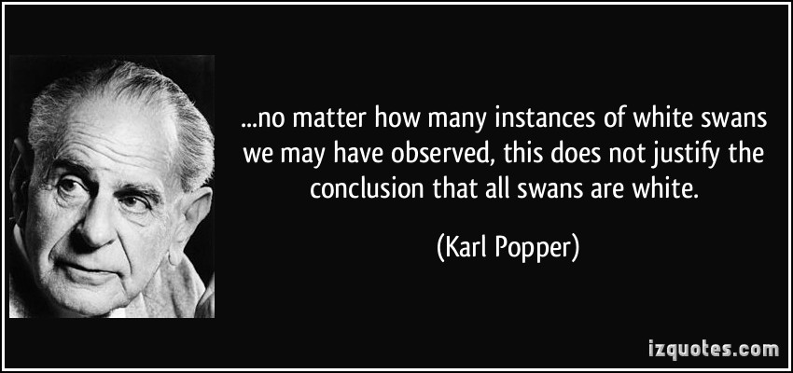

Falsification does not mean something is false; rather that if it is false, then this can be shown by observation or experimentation. Karl Popper famously inferred in the quote above that ‘All swans are white’ can be falsified by observing just one black swan. Therefore true science should be able to not only show that the data is true but also that it can be shown to be untrue.

One of the main theorists lacking scientific objectivity is Freud. It may be difficult to provide evidence to support his theories, but it is equally impossible to falsify them too!

Predictive power

Theories should provide general laws or principles to allow predictions of future behavior. Many theories in psychology do take a nomothetic (apply to the whole population) approach, but some take an idiographic (apply to individuals or small groups) approach, such as the Individual differences approach. These approaches are just as valuable to our understanding of human behavior. In fact it is the differences between individuals which make psychology so fascinating.

Ethical Considerations

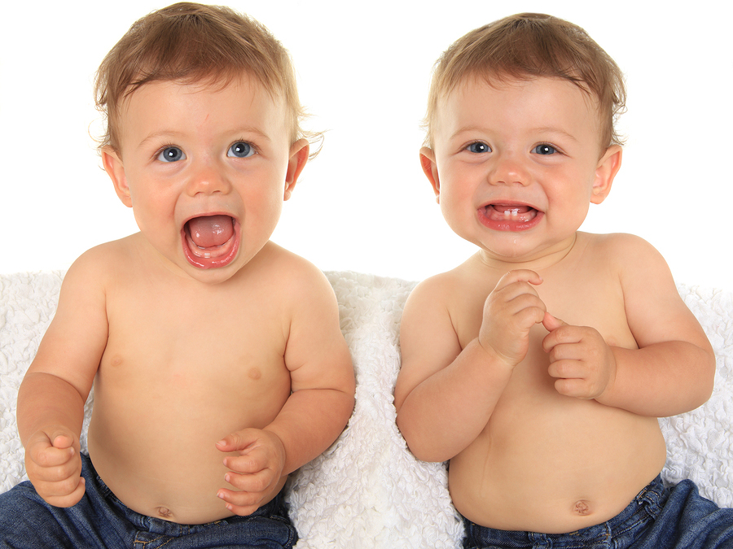
A further obstacle in the path of scientific objectivity is ethical dilemma. We cannot isolate and test variables without being cruel or unethical. For example, the only way to scientifically test the nature/nurture debate would be to isolate identical twins and raise them in completely different environments!!!

Animals have been used where humans can’t be to overcome some ethical issues. However, we cannot necessarily apply the findings from animal research to humans, we are very different.

Task: Do you think Psychology is a science? What is the evidence for and against? Use studies as evidence to illustrate your answer.

Reporting Psychological Investigations

Investigations must be written up in the style of a scientific report. All the pages must be numbered and must be written in the third person passive. This means in the past tense and don’t say ‘I’ or ‘we’.

It must be concise and precise, this is good scientific practice and you will be under time pressure in the examination.

Reports must include the following sections in this precise order: -

Title, Content page, Abstract, Introduction, Procedure, Results, Discussion, References, Appendices



Title

This must be concise and to the point, yet clear enough to give the reader an idea of the investigation’s central concerns.

Contents Page

Every page must be numbered and every section must be recorded along with the page number on the contents page.

Abstract

This is a brief summary of the entire investigation (100-150 words maximum) and is actually written last, although it appears at the beginning of the report.
You need to include: -
- A one-sentence summary, giving the topic to be studied (aim and main background study)
- Description of participants and sampling technique
- Description of procedure
- Description of results (quote statistics and significance level)
- What does it mean? Conclusion, implications and suggestions for future research.

Introduction

In this section you review all the background research relevant to your investigation. You must clearly quote your aim and operationalised hypothesis and null hypothesis. E.g. Males will score higher on an aggression questionnaire than females. (One-tailed) Any difference between male and female scores on an aggression questionnaire will be due to chance.

- Review of background research
- Aim
- Hypothesis and null hypothesis

Procedure

This section has four sub-sections, each should be sub-titled. The aim is to produce a sufficiently detailed method for someone to be able to exactly replicate your study.

Design and overview

State what research method you are using and why. The choice of research design (independent measures, repeated measures, matched pairs or correlation) should also be stated and justified. If your experiment is an experiment state the operationalised IV and DV. Also mention any other variables that you have controlled such as gender or age and any confounding variables you were unable to control i.e. individual differences, situation etc. Explain how you will deal with ethical issues. Remember not to use any participants under the age of 16. You must ensure that you have informed consent, protect them from harm, give your participants the right to withdraw, keep their details confidential, debrief them etc.

- Research method
- Research Design
- Variables
- Controls
- Ethics

Participants & investigators

Who were your participants and how did you select them. You need to describe your sampling procedure and give relevant details such as age, gender, social class and educational background etc. about your participants, whilst ensuring they remain anonymous. You will probably use an opportunity sample selected from your own college, do not even give the name of the college, and instead say ‘a local 6th form’. If you have more than one condition in your investigation, explain how participants were allocated to conditions, this might be obvious if the IV was age or gender. For ethical reasons do not use anyone under 16, as you would require parental consent.

- Investigator (s) – Just yourself or a small group (names)?
- Number of participants and anonymous details
- Sampling procedure
- Number in each condition and how they were allocated
Apparatus

A list of everything you used as part of your investigation. Refer to copies of any materials in appendices.
Procedure

This needs to explain exactly what you did from start to finish, including any pilot studies, design of stimulus material etc. Remember to refer the reader to the appendices for standardised instructions, debrief, copies of stimulus materials etc.

Results

Descriptive results aim to be as clear and precise as possible. A summary table of results should be presented, along with appropriate, fully labelled graphs. However, be careful with graphs, one is usually enough, the important thing is clarity. Make sure you provide a paragraph underneath your table and graph that fully explains what they show. Do not include raw data here – refer the reader to the appendices.

e.g.
Summary Table of Results – Table to show average scores on an aggression questionnaire of males and females.

 | Males | Females
Mean | 20.6 | 14.3
Standard Deviation | 3.1 | 4.1

This shows on average that………
The variation in male and female aggression scores shows that…….
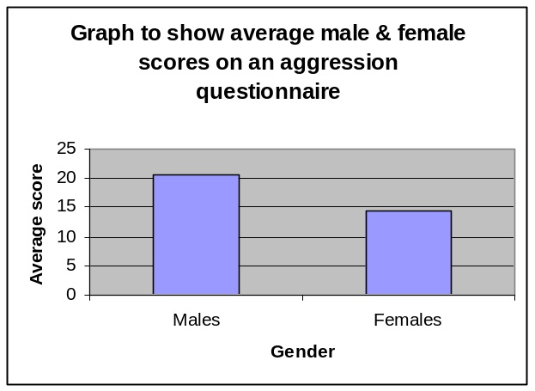
The graph shows that…………

Analysis of results

This is where you present the results of your inferential statistics. In other words were your results statistically significant – Is it possible to reject the null hypothesis? Your statistical test must be fully justified with reference to the data and your results quoted in terms of reject/accept the null hypothesis. All calculations and critical value tables should be included in the appendices (This means the computer printouts of your results).

To recap: -

Choosing an appropriate statistical test

 | Test of Difference |  | Relationship
Level of Measurement | Independent Measures Design | Repeated Measures Design or Matched Pairs | Correlation
Nominal (Frequency) | Chi-square | Sign Test | Chi-Square
Ordinal, Interval or Ratio (Ranked) | Mann-Whitney U Test | Wilcoxon matched pairs signed ranks test | Spearman’s Rank Order Correlation Coefficient

E.g. This investigation was a test of difference and utilised an independent measures design because a difference between two groups (males and females) was being looked for. The questionnaires generated ordinal data in the form of scores, so the appropriate statistical test was the Mann Whitney U Test. After calculation U = 18 (see appendices Pg…. for calculations), the critical value for a one tailed test at 5% = 27. The result was statistically significant and therefore it was necessary to reject the null hypothesis that any difference between male and female scores on an aggression questionnaire was due to chance.

- Summary table
- Graphs
- Descriptions of table and graphs
- Justification of statistical test
- Results quoted in terms of null hypothesis

Discussion
Explanation of findings

In the results section you stated your findings in statistical terms. Now state them in psychological terms, relating the finding to your initial aims/hypothesis. Also state whether or not your findings support those of your background study. You may have additional findings to report aside from those related to the hypotheses, such as observations made when collecting data.
In this section you need to explain in non-statistical language exactly what you found and what it means. Comment on the strength of the relationship or effect you discovered, for example were your results only just significant or not or was it a very strong effect. If the results went in totally the opposite direction to what you were expecting, comment on this too. Finally, briefly explain why you think you found what you did. Never, ever, use the words prove or disprove, instead say you found evidence to suggest, support etc.

- What did you find?
- Why?
- What does it mean?

Limitations and modifications

Take a critical look at your own research. What went really well, what were the strengths? What was wrong with it- if you were to do it again what would you do differently? Be honest here – it is more important to show an awareness of weaknesses than produce a perfect piece of research. Remember to pay particular attention to confounding variables that could have affected your results and sampling size/technique. When suggesting modifications it is not necessary to be constrained by practical concerns such as time and money because this is what you would do in a perfect world!

- Strengths
- Weaknesses
- Modifications (things to change if repeated)

Implications and suggestions for further research

The last section of the discussion deals with the implications, applications of your research and ideas for future research. How relevant are your results to the real world? What practical applications do they have? For example, if you did a memory experiment your findings could be relevant to education, examination revision and generally to improving memory. Eyewitness testimony research has important implications for criminal justice.
You should try to suggest some ideas for further research, but note these should be different to the modification you suggested in the previous section. The great thing here is you don’t have to worry about mundane practicalities, as you are not going to actually carry out the research, so it is quite acceptable to suggest a 20 year longitudinal study or a cross-cultural comparison etc.

- Real world applications and implications
- Further research

References

Your background study should be referenced, as should any internet resources such as psychometric tests, questionnaires etc., these should include date accessed as well as website address.

e.g.
Bandura A, Ross D & Ross S (1961) Transmission of aggression through imitation of aggressive models Journal of Abnormal & Social Psychology 63: 375-382
All references should be alphabetical order.

Task: -
Write the following references in the correct order: -
London | Duck, S | Sage | (1992) | Human Relationships
Cambridge | Gajic, D | Illuminate | (2018) | Secrets of a Psychology Teacher
pgs 671-684 | (1972) | Craik & Lockhart |  | Levels of Processing Journal of Verbal Learning & Verbal Behaviour 11
Academic Press | New York | R L Selman | (1980) | The growth of interpersonal understanding: developmental and clinical analyses
(1993) | S Bem | New Haven | Yale University Press | The lenses of gender: transforming the debate on sexual inequality

Appendices

Any additional information such as raw data, statistical calculations, stimulus material, standardised instructions and debrief etc. Each appendix should be numbered, have a full title and be referred to somewhere in the main body of the report.

Levels of Data

Nominal data: a level of measurement where data are in separate categories (Frequencies).
Ordinal data: a level of measurement where data are ordered in some way. (Interval & Ratio data can be converted to ordinal)

Ordinal data is data that can be place in rank order e.g. 1st, 2nd, 3rd etc.
e.g. Highest gets rank value of 1 etc.

Scores | 37 | 34 | 33 | 31 | 28 | 23 | 21 | 15 | 14 | 13
Rank | 1 | 2 | 3 | 4 | 5 | 6 | 7 | 8 | 9 | 10
Shared Ranks
Scores | 37 | 34 | 34 | 34 | 28 | 23 | 21 | 14 | 14 | 13
Rank | 1 | 2 | 3 | 4 | 5 | 6 | 7 | 8 | 9 | 10
Ranks | 1 | 3 | 3 | 3 | 5 | 6 | 7 | 8.5 | 8.5 | 10

Task: - Rank the following data sets

- 3,4,5,5,6,7,7,9,9,10
- -2, 0,7,-1,3,4,5,8,9,10
- 23,23,23,23,23,21,20,31,28,29
- 27,3,19,45,6,7,9,3,3,27

Interval data /Ratio data: a level of measurement where units of equal measurements (a scale with equal intervals) are used e.g. minutes, kilograms, number of words recalled in a memory test or percentage score in an exam. Ratio data is on a scale, but has a true zero e.g. weight/height, time, distance.

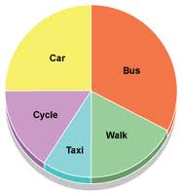




Looking at the 3 pictures above, find examples, of each type of data:

Nominal data | Ordinal data | Interval/Ratio data

Now identify the level of the data in each of these examples:
- Number of children (average age 4.5 years) engaged in type of play
Non-play | Solitary | Associative | Parallel | cooperative
8 | 5 | 17 | 23 | 6

……………………………………………………………………………………………………………………………………

- Podium positions, Monaco Grand Prix 2010
Mark Webber, Sebastian Vettel, Robert Kubica
……………………………………………………………………………………………………………………………………

- Rosenthal and Fode (1963) Time in minutes taken by rats to correctly find their way round a maze.
……………………………………………………………………………………………………………………………………

- Holmes & Rahe devised a stress scale, with arbitrary numerical values given to a series of life events such as ‘death of spouse’ or ‘getting married’
……………………………………………………………………………………………………………………………………
- Bandura’s Bobo Doll study, behaviours observed: aggressive, non-aggressive
……………………………………………………………………………………………………………………………………
- Schacter& Singer (1962) attempted to estimate how emotional Pps were feeling, using a scale to measure happiness, and another to measure anger.
……………………………………………………………………………………………………………………………………
- Collins & Quillian (1969) measured time taken in seconds, to decide if statements were true or false.
……………………………………………………………………………………………………………………………………

- Lang & Lazovik (1963) measured phobics’ scores on a 19-point scale ‘snake avoidance test’.

……………………………………………………………………………………………………………………………………

Inferential statistics

The aim of inferential statistics is to discover if your results are statistically significant. A statistically significant result is one which is unlikely to have occurred through chance. Usually, psychologists use the 5% level (0.05), this means that just 1 in 20 of results could have occurred due to chance. We express our results in terms of the Null Hypothesis, if a result is statistically significant we can reject the null hypothesis, if the result is not statistically significant we must accept the null hypothesis. In other words we need to be 95% confident that the results were due to the manipulation of the IV in order to reject the null hypothesis.

Null Hypothesis: - Any change (difference) between the two conditions is due to chance.

The concept of statistical significance is linked to the mathematical concept of probability.

Task: - Complete the following exercise

On a scale of 1-99 rate the following statements for probability 1 = almost impossible and 99 = almost certain (Remember the only thing certain is death and the only thing impossible immortality!)

- You winning the lottery
- It raining in the next week
- Dreaming of elephants this week
- Having a day off ill this term
- Becoming a famous entertainer
- Becoming a parent in your lifetime
- A cure for cancer being discovered in your lifetime
- If you spin a coin it will come down heads
- If you spin two coins they will both come down heads
- Passing all your A levels

Because we used a scale between 1-99 your answers are expressed as percentages. Convert them into fractions and then decimals e.g. 50% is ½ or 0.5 (50/100 cancelled down to lowest possible) 50% move the decimal point two places to the left)

In psychology the most common level of significance is 5% (e.g. 1 in 20 or p≤0.05) (the p stands for probability and ≤less than or equal to). This level is seen as a representing a balance between a type I and type II error. The 5% level is fine for Psychology, but clearly if we were experimenting on a new drug , a 1 in 20 chance that it might kill you are not very good odds and the level would have to be significantly reduced.

Type I Error | False Positive. Rejecting the null hypothesis, when there is a possibility that the results were due to chance. Often caused by using a significance level that is too lenient e.g. 10%, 0.10, 1 in 10, p≤0.10. Not being cautious enough.
Type II Error | False Negative. Accepting the null hypothesis, when there is a possibility that the results were significant. Often caused by using a significance level that is too strict e.g. 1%, 0.01, 1 in 100, p≤0.01. Being over cautious.

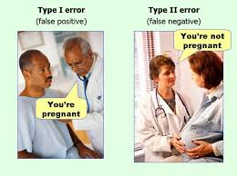

Choosing an appropriate non-parametric statistical test

 | Test of Difference |  | Relationship
Level of Measurement | Independent Measures Design | Repeated Measures Design or Matched Pairs | Correlation
Nominal (Frequency) | Chi-square | Sign Test | Chi-Square
Ordinal, Interval or Ratio (Ranked) | Mann-Whitney U Test | Wilcoxon matched pairs signed ranks test | Spearman’s Rank Order Correlation Coefficient

After performing the necessary calculations for these tests, you will need to look up your calculated value in the critical value tables (back of handout) to discover if your result is statistically significant. All these tests except the Mann Whitney U and Wilcoxen need a calculated value which exceeds the critical value in order to be significant.

To re-cap: -

Define the following terms and fill in the tables: -

Independent Measures Design |  | Repeated Measures Design |  | Matched Pairs Design
+ | - | + | - | + | -

Spearman’s Rank Order Correlation Coefficient

It is expected that if a person likes the group Guns N Roses, they are unlikely to also like Jedward!
What sort of correlation would this show?
When 10 participants were asked to rate these two groups of a scale of 1-10 the results were as follows: -

Guns n Roses | Jedward
4 | 9
5 | 7
10 | 2
8 | 3
9 | 5
1 | 9
5 | 5
3 | 6
8 | 2
7 | 7

Draw a scatter graph; don’t forget the line of best fit. What does your graph show? Then rank the scores.

Guns n Roses | Rank 1 | Jedward | Rank 2 | d | d²
4 | 3 | 9 | 9.5 | -6.5 | 42.25
5 | 4.5 | 7 | 7.5 | -3 | 9
10 | 10 | 2 | 1.5 | 8.5 | 72.25
8 | 7.5 | 3 | 3 | 4.5 | 20.25
9 | 9 | 5 | 4.5 | -4.5 | 20.25
1 | 1 | 9 | 9.5 | -8.5 | 72.25
5 | 4.5 | 5 | 4.5 | 0 | 0
3 | 2 | 6 | 6 | -4 | 16
8 | 7.5 | 2 | 1.5 | 6 | 36
7 | 6 | 7 | 7.5 | -1.5 | 2.25
 |  |  |  | Σd² | 290.5

Rs = 1 - 6Σd²
n(n²-1)

Rs = 1- 6x290.5
10(10²-1)
Rs = 1 – 1743
990

Rs –= 1 – 1.76

Rs = -0.76

Look up the results in the critical value tables N =10, significant level = 0.05, 5%. (nb. The – or + simply tells you whether it is a positive or negative correlation)

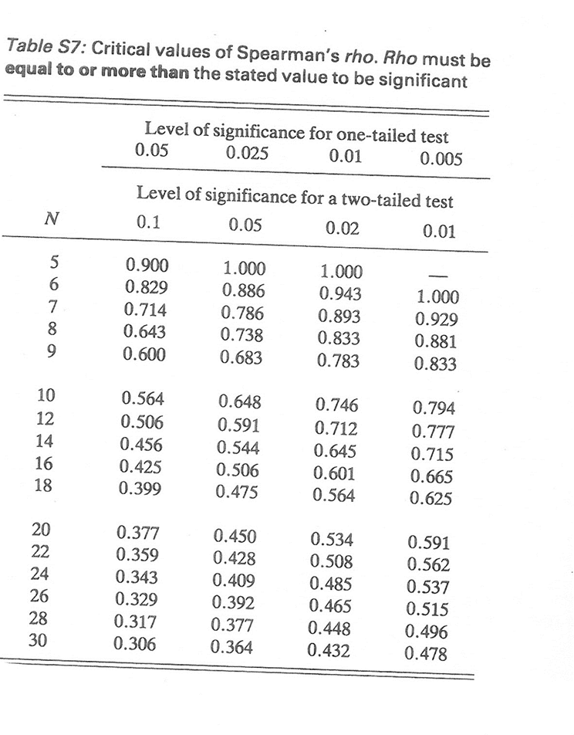

Sign Test

This test simply involves counting up the number of positive and negative signs.

Example: -

A study was conducted to discover if students changed their attitude towards the death penalty after watching ‘The Green Mile’.

Experimental Hypothesis: - Watching the film ‘The Green Mile’ will influence student’s attitudes to the death penalty. (non-directional – two-tailed)
Participant No: | Attitude before film | Attitude after film | Direction of Influence
1 | For | Against | -
2 | For | Against | -
3 | For | Against | -
4 | Against | Against | No change
5 | For | Against | -
6 | For | Against | -
7 | For | Against | -
8 | For | Against | -
9 | For | Against | -
10 | Against | For | +

- Add the number of times the least frequent sign appears. In this case the + sign, so S = 1.
- Look at the critical value tables to obtain the critical value for S, number of score = 9 (as pairs of scores with no change are omitted), p=0.05.

- Critical Value for a two tailed test = 1, therefore the Null hypothesis can be rejected the test result was statistically significant (most people did change their opinion after watching the film).
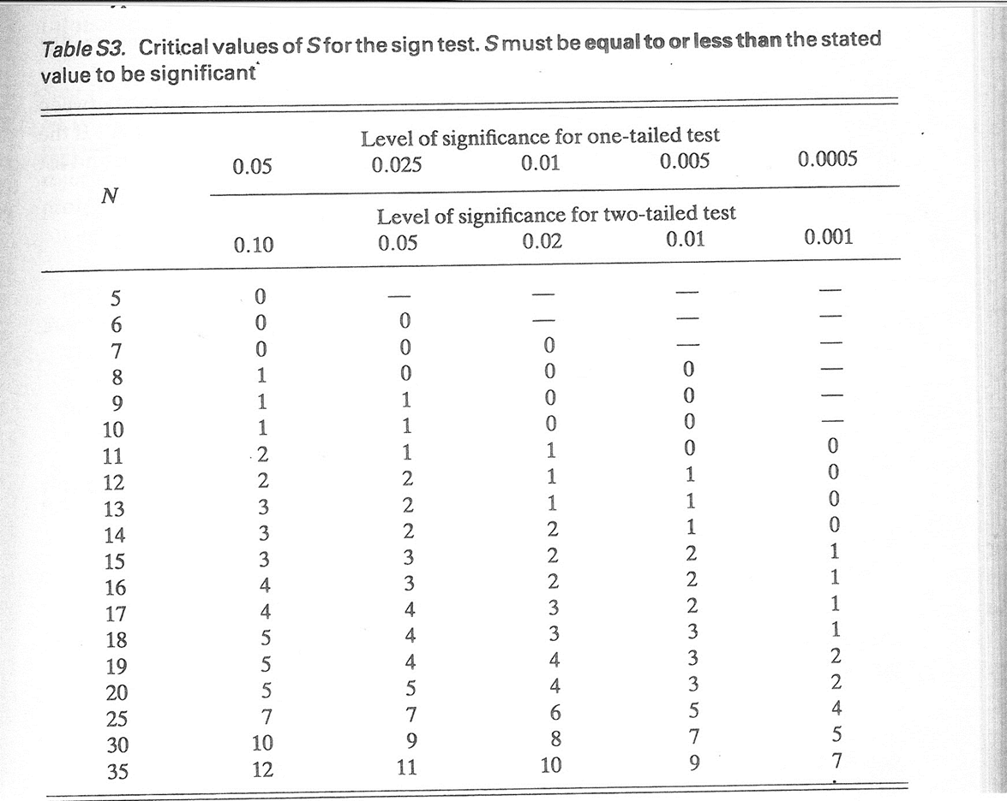

Chi- Square Test X²

This test compares observed frequencies (those actually obtained) with expected frequencies (the averages which would be observed if the null hypothesis were true).

X² =Σ (O-E)2 O = Observed Values E = Expected values
E

Example: - Piaget Conservation Experiment
Hypothesis: 7 year olds will be more likely to be able to conserve than 5 year olds. (Directional - One-tailed)

Data must be first entered into a contingency table: -

 | Number able to conserve | Number unable to conserve | Row Total (RT)
5 year olds | 8 ¹ | 12 ² | 20
7 year olds | 17 ³ | 3 ⁴ | 20
Column Total (CT) | 25 | 15 | GT = 40

Degrees of freedom = (No: of rows -1)(No: of columns – 1)
df = 1x1 = 1

Expected values = RT x CT
GT
Expected Value Cell 1 = 20 X 25 = 12.5
40
Expected Value Cell 2 = 20 X 15 = 7.5
40
Expected Value Cell 3 = 20 X 25 = 12.5
40
Expected Value Cell 4 = 20 X 15 = 7.5
40
 | o | e | o-e | (o-e)² | (o-e)²  e
Cell 1 | 8 | 12.5 | -4.5 | 20.25 | 1.62
Cell 2 | 12 | 7.5 | 4.5 | 20.25 | 2.7
Cell 3 | 17 | 12.5 | -4.5 | 20.25 | 1.62
Cell 4 | 3 | 7.5 | 4.5 | 20.25 | 2.7
 |  |  |  |  | Σ = 8.64

Calculated Value = 8.64

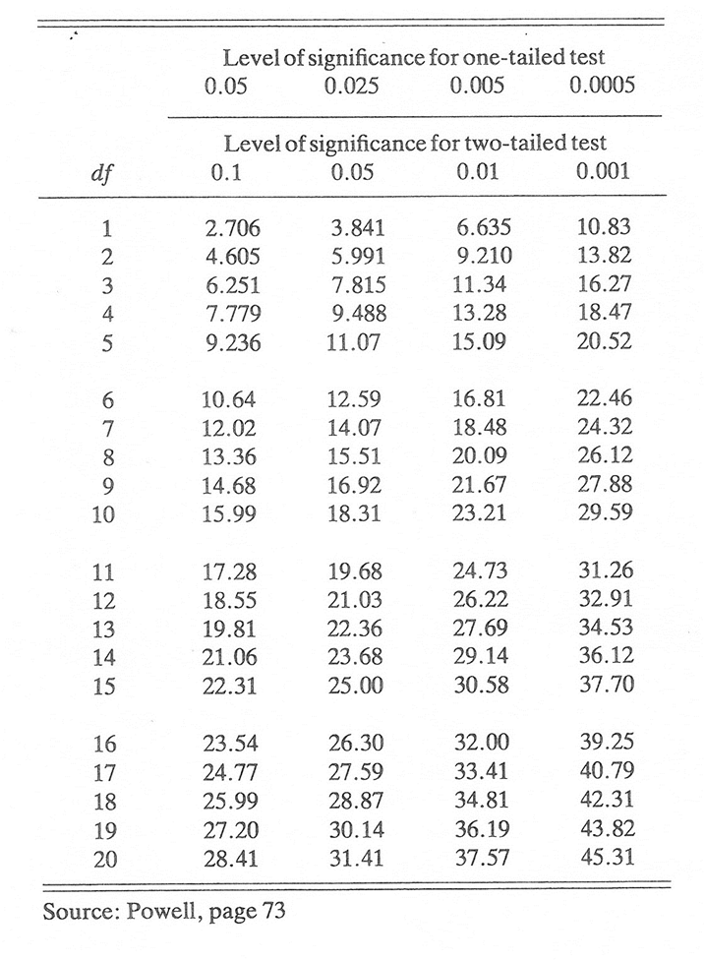
Critical value for a one tailed test, 1 df at 5% = 2.706, therefore the result is significant, the null hypothesis can be rejected. It would appear that 7 year olds are more likely to be able to conserve than 5 year olds.

Mann Whitney U Test

Hypothesis: - Males will score higher on an aggression questionnaire than females. (directional – one-tailed).

Male Scores | Female Scores
25 | 14
17 | 13
16 | 12
10 | 18
12 | 11
18 | 9
16 | 10
17 | 16
15 | 15
14 | 11
Mean = 16 | Mean = 12.9

Formula U = N₁ N₂ + N₁ (N₁ +1) - T
2
Rank all your data together: -

9 | 10 | 10 | 11 | 11 | 12 |  | 12 | 13 | 14 | 14 | 15 |  | 15 | 16 | 16 | 16 | 17 |  | 17 | 18 | 18 | 25
1 | 2 | 3 | 4 | 5 | 6 |  | 7 | 8 | 9 | 10 | 11 |  | 12 | 13 | 14 | 15 | 16 |  | 17 | 18 | 19 | 20
1 | 2.5 | 2.5 | 4.5 | 4.5 | 6.5 |  | 6.5 | 8 | 9.5 | 9.5 | 11.5 |  | 11.5 | 14 | 14 | 14 | 16.5 |  | 16.5 | 18.5 | 18.5 | 20
Male Scores |  |  |  |  |  | Ranks |  |  |  |  |  | Female Scores |  |  |  |  |  | Ranks
25 |  |  |  |  |  | 20 |  |  |  |  |  | 14 |  |  |  |  |  | 9.5
17 |  |  |  |  |  | 16.5 |  |  |  |  |  | 13 |  |  |  |  |  | 8
16 |  |  |  |  |  | 14 |  |  |  |  |  | 12 |  |  |  |  |  | 6.5
10 |  |  |  |  |  | 2.5 |  |  |  |  |  | 18 |  |  |  |  |  | 18.5
12 |  |  |  |  |  | 6.5 |  |  |  |  |  | 11 |  |  |  |  |  | 4.5
18 |  |  |  |  |  | 18.5 |  |  |  |  |  | 9 |  |  |  |  |  | 1
16 |  |  |  |  |  | 14 |  |  |  |  |  | 10 |  |  |  |  |  | 2.5
17 |  |  |  |  |  | 16.5 |  |  |  |  |  | 16 |  |  |  |  |  | 14
15 |  |  |  |  |  | 11.5 |  |  |  |  |  | 15 |  |  |  |  |  | 11.5
14 |  |  |  |  |  | 9.5 |  |  |  |  |  | 11 |  |  |  |  |  | 4.5
 |  |  |  |  |  | T = 129.5 |  |  |  |  |  |  |  |  |  |  |  | T = 80.5

U¹ = 10 X 10 + 10(10 +1) - 129.5
2
U¹ = 100+ 110 – 129.5
2
U¹= 155-129.5 = 25.5

U² = 10 X 10 + 10(10 +1) - 80.5
2
U² = 100+ 110 – 80.5
2
U² = 155-80.5 = 74.5

Select whichever U value is the smaller as your calculated value, in this case U¹ = 25.5

The critical value for a one-tailed test at 5% N = 10 is 27, therefore the result is significant and it is necessary to reject the null hypothesis. Evidence has been discovered to suggest that males did score higher on an aggression questionnaire than females.

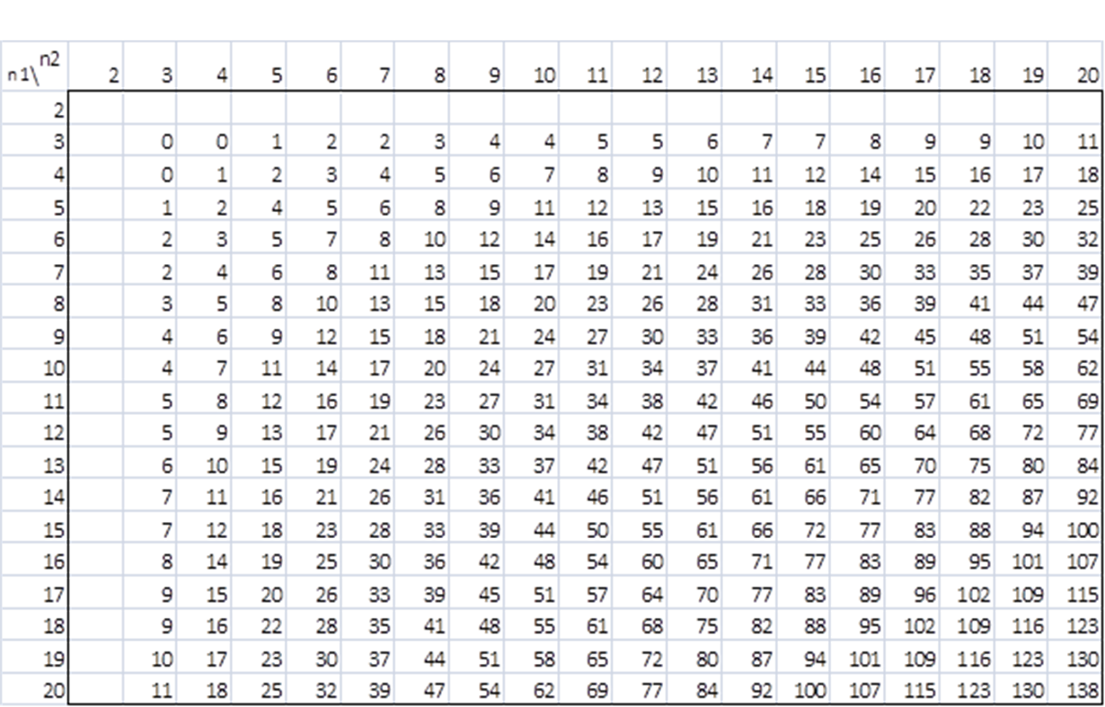
The Wilcoxen Matched Pairs Signed Ranks Test

Hypothesis: Participants will score lower on a reaction test after consuming alcohol. (Directional – one-tailed)

Before Alcohol score | After Alcohol score | Difference | Rank
20 | 17 | 3 | 4
14 | 12 | 2 | 2.5
14 | 16 | -2 | 2.5
19 | 12 | 7 | 9
15 | 16 | -1 | 1
19 | 14 | 5 | 6
13 | 13 | 0 | Omitted
16 | 11 | 5 | 6
19 | 13 | 6 | 8
16 | 11 | 5 | 6

Rank the differences ignoring the signs, giving the lowest difference rank 1

1 | 2 | 2 | 3 | 5 | 5 | 5 | 6 | 7
1 | 2 | 3 | 4 | 5 | 6 | 7 | 8 | 9
1 | 2.5 | 2.5 | 4 | 6 | 6 | 6 | 8 | 9

Sum of ranks with + = 41.5
Sum of ranks with - = 3.5

The lowest value is T, your calculated value.

Calculated Value = 3.5

Critical value for a one tailed test at 5%, N = 9 (no difference scores are omitted) = 8
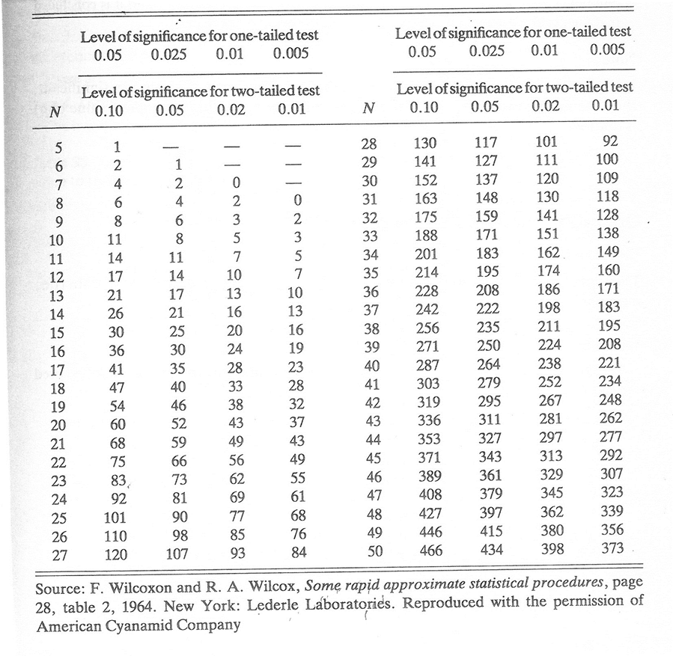
There the result is significant, the null hypothesis must be rejected as evidence has been found to support the view that alcohol effects reaction times.

Decide which test is appropriate in the following scenarios. You need to think about whether it is a test of difference or association, the type of date (ordinal or nominal) and the experimental design (independent, repeated, matched pairs or correlation)

- An experiment predicting that female IQ scores on a standard IQ test will be higher than males.

Difference or Association: -

Experimental Design: -

Type of Data:

Test:

- An analysis of the relationship between happiness and self-esteem, predicting that the higher a person’s rated their own self-esteem, the higher they would rate their happiness.

Difference or Association: -

Experimental Design: -

Type of Data:

Test:

- An observation of driver behaviour to test that more males than females stop at zebra crossings for pedestrians.

Difference or Association: -

Experimental Design: -

Type of Data:

Test:

- Males will spend more time watching TV than females.

Difference or Association: -

Experimental Design: -

Type of Data:

Test:

- A survey of students expecting to find that those with internet access estimate time spent on homework to be greater than those with no internet access.

Difference or Association: -

Experimental Design: -

Type of Data:

Test:

- Satisfaction levels among students over the course of a college day predicting that students will report higher satisfaction ratings after lunch than before.

Difference or Association: -

Experimental Design: -

Type of Data:

Test:

- A piece of research being conducted in a hospital out-patient department expecting to find that blood pressure goes up as waiting time increases.

Difference or Association: -

Experimental Design: -

Type of Data:

Test:

- A cohort study of identical twins predicting that they will have very similar IQ test scores as measured by standardised IQ tests.

Difference or Association: -

Experimental Design: -

Type of Data:

Test:

- A piece on biopsychological research predicting that asthma sufferers will score higher on anxiety scales than people who do not have asthma.

Difference or Association: -

Experimental Design: -

Type of Data:

Test:

- Research conducted in an eating disorder clinic aiming to show bulimics will demonstrate food preferences for saltier snacks, while anorexics will demonstrate preferences for sweeter snacks.

Difference or Association: -

Experimental Design: -

Type of Data:

Test:

- A survey of gender and self-esteem predicting that males have higher self-esteem than females.

Difference or Association: -

Experimental Design: -

Type of Data:

Test:

- An observational piece of research on gender and pro-social behaviour predicting that females are more likely to give up their seat on a crowded bus.

Difference or Association: -

Experimental Design: -

Type of Data:

Test:

- A research project conducted by the ministry of Defence to assess the effects of anxiety on active service, predicting that soldiers will score higher on anxiety scales on their return from active service than before active service.

Difference or Association: -

Experimental Design: -

Type of Data:

Test:

- Fathers are more likely than mothers to report feelings of euphoria at the birth of their first child.

Difference or Association: -

Experimental Design: -

Type of Data:

Test:

- Mothers are more likely than fathers to report feelings of panic on learning that they are to become parents of twins.

Difference or Association: -

Experimental Design: -

Type of Data:

Test:

- Women over 40 are more likely than those under 40 to show symptoms of decorxeria (an obsessive relationship with décor and home furnishing, prevalent in female psychology teachers!)

Difference or Association: -

Experimental Design: -

Type of Data:

Test:

- A study to discover if lesson observation ratings (outstanding, good, requires improvement, inadequate) between teachers working in the same department are very similar.

Difference or Association: -

Experimental Design: -

Type of Data:

Test:

- Identical twins take part in an experiment on the effects of sleep deprivation on memory. One twin is in the experimental group (deprived of one night’s sleep), the other the control (normal night’s sleep). The next day they given a memory test, the maximum possible score is 25.

Difference or Association: -

Experimental Design: -

Type of Data:

Test:

- Participants take part in an experiment on the effects of sleep deprivation on memory. Half the participants are allowed to sleep, the other half are kept awake. The next day they given a memory test, the maximum possible score is 25.

Difference or Association: -

Experimental Design: -

Type of Data:

Test:

- It is expected that older women (over 40) will choose a larger body shape silhouette as their ideal than younger women (under 20). All participants are given a questionnaire with 5 different body shapes (ranging from size 8 -16) on and are asked to choose their ideal shape.

Difference or Association: -

Experimental Design: -

Type of Data:

Test:

- It is expected that the amount of rainfall is related to the sales of umbrellas.

Difference or Association: -

Experimental Design: -

Type of Data:

Test:

- A group of people are asked whether or not they are in favour of animal experimentation. They are then shown a film on the subject and asked again.

Difference or Association: -

Experimental Design: -

Type of Data:

Test:

Parametric Tests

Conditions for Parametric Testing: -

- Data is interval or ratio
- Data is normally distributed
- Standard deviations (variances) for the two sets of data are similar

Data | Test of Difference |  | Relationship
 | Independent Measures | Repeated Measures/Matched Pairs | Correlation
Interval/Ratio | Unrelated t-test | Related t-test | Pearson’s

Exam Questions (A Level)

1) Read the item and then answer the questions that follow.

A psychologist wanted to see if verbal fluency is affected by whether people think they are presenting information to a small group of people or to a large group of people.
The psychologist needed a stratified sample of 20 people. She obtained the sample from a company employing 60 men and 40 women.
The participants were told that they would be placed in a booth where they would read out an article about the life of a famous author to an audience. Participants were also told that the audience would not be present, but would only be able to hear them and would not be able to interact with them.
There were two conditions in the study, Condition A and Condition B. Condition A: 10 participants were told the audience consisted of 5 listeners.
Condition B: the other 10 participants were told the audience consisted of 100 listeners.
Each participant completed the study individually. The psychologist recorded each presentation and then counted the number of verbal errors made by each participant.
Identify the dependent variable in this study.
[2 marks]

2) Write a suitable hypothesis for this study.
[3 marks]
3) Identify one extraneous variable that the psychologist should have controlled in the study and explain why it should have been controlled.
[3 marks]
4) Explain one advantage of using a stratified sample of participants in this study. [2 marks]
5) Explain how the psychologist would have obtained the male participants for her stratified sample. Show your calculations.
[3 marks]
6) The psychologist wanted to randomly allocate the 20 people in her stratified sample to the two conditions. She needed an equal number of males in each condition and an equal number of females in each condition. Explain how she would have done this.
[4 marks]
7) Read the item and then answer the questions that follow.
The results of the study are given in Table 1.
Table 1: Mean number of verbal errors and standard deviations for both conditions
 | Condition A (believed audience of 5 listeners) | Condition B (believed audience of 100 listeners)
Mean | 11.1 | 17.2
Standard Deviation | 1.30 | 3.54

What conclusions might the psychologist draw from the data in Table 1? Refer to the means and standard deviations in your answer.
[6 marks]
8) Read the item and then answer the question that follows.
The psychologist had initially intended to use the range as a measure of dispersion in this study but found that one person in Condition A had made an exceptionally low number of verbal errors.

Explain how using the standard deviation rather than the range in this situation, would improve the study.
[3 marks]

9) Name an appropriate statistical test that could be used to analyse the number of verbal errors in Table 1. Explain why the test you have chosen would be a suitable test in this case.
[4 marks]
10) The psychologist found the results were significant at p<0.05. What is meant by ‘the results were significant at p<0.05’?
[2 marks]

11) Briefly explain one method the psychologist could use to check the validity of the data she collected in this study.
[2 marks]
12) Briefly explain one reason why it is important for research to undergo a peer review process.
[2 marks]
13) Read the item and then answer the question that follows.
The psychologist focused on fluency in spoken communication in her study. Other research has investigated sex differences in non-verbal behaviours such as body language and gestures.
Design an observation study to investigate sex differences in non-verbal behaviour of males and females when they are giving a presentation to an audience.
In your answer you should provide details of:
- the task for the participants
- the behavioural categories to be used and how the data will be recorded
- how reliability of the data collection might be established
- ethical issues to be considered. [12 marks]
48 marks total

